**House Price Prediction Web Application – Documentation**

**Introduction**

This document provides a detailed explanation of the House Price Prediction web application. This application predicts house prices based on input features such as the number of bedrooms, bathrooms, and square footage. The application uses a machine learning model to make predictions and is developed using Flask, a lightweight web framework for Python.

**Project Structure**

The project directory is structured to maintain clarity and separation of concerns. The root directory contains the main application and model files, along with directories for templates, static files, and data. The app.py file is the main Flask application file that handles the web server and routes. The model.py file is responsible for training and saving the machine learning model. The templates directory contains HTML templates, while the static directory contains CSS files. The data directory holds the dataset file used for training the model. The README.md file provides an overview of the project, setup instructions, and usage details.

**Setup Instructions**

To set up and run the project, follow these steps:

Clone the repository using the command git clone <your-repo-url>, and navigate to the project directory with cd house_price_prediction.

Install the required libraries by running pip install Flask pandas scikit-learn.

Run the model training script with python model.py. This script will load the dataset, preprocess it, train a Linear Regression model, and save the model as model.pkl.

Run the Flask application with python app.py.

Open your web browser and navigate to http://127.0.0.1:5000/ to access the application.

**Application Functionality**

The web application features a user-friendly form where users can input the house features, including the number of bedrooms, bathrooms, and total square footage. Upon submitting the form, the application uses the trained machine learning model to predict the house price based on these input features. The predicted price is then displayed on the web page for the user.

Form Input

The web form allows users to input the house features:

Bedrooms: Number of bedrooms in the house.

Bathrooms: Number of bathrooms in the house.

Square Feet: Total square footage of the house.

Screenshot of the form input:  
  
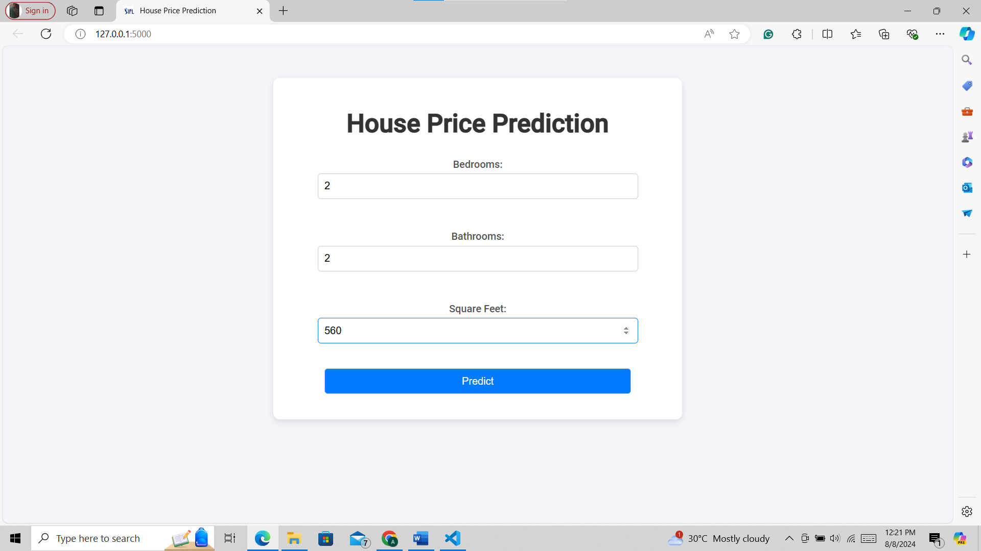

Prediction Output

After submitting the form, the application predicts the house price using the trained model and displays the result on the web page.

Screenshot of the prediction output:

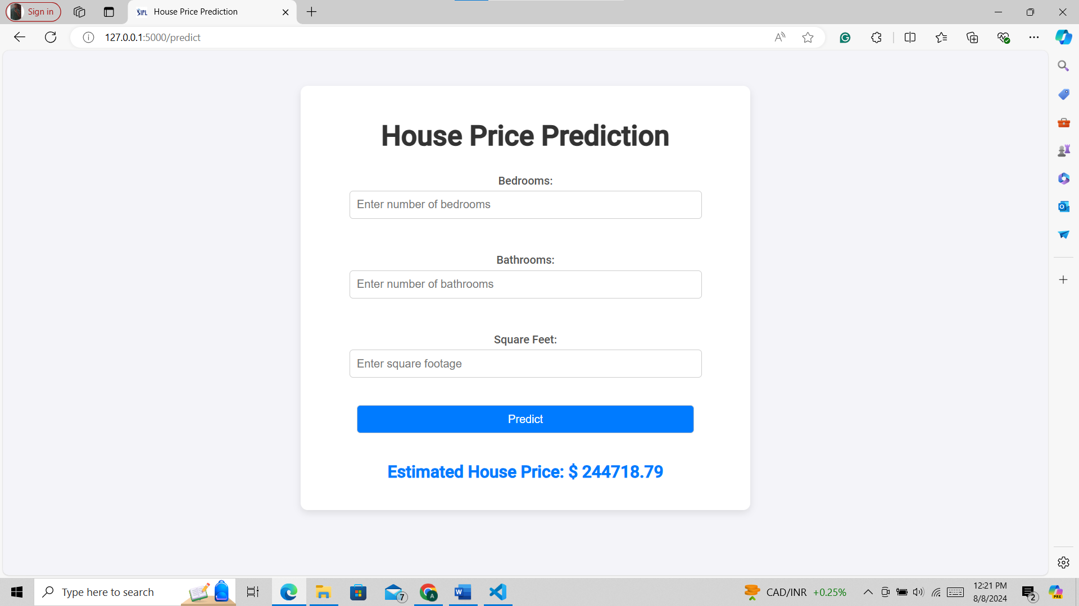

**Model Training**

The model is trained using the housing_data.csv dataset located in the data directory. The model.py script performs several steps to prepare and train the model:

Load the dataset: The script reads the CSV file using pandas to load the data into a DataFrame.

Preprocess the dataset: The script selects relevant features (bedrooms, bathrooms, sqft_living) and the target variable (price).

Split the data: The dataset is split into training and testing sets using train_test_split from scikit-learn.

Train the model: A Linear Regression model is trained on the training set.

Save the model: The trained model is saved to a file named model.pkl using pickle.

**Conclusion**

This documentation provides a comprehensive overview of the House Price Prediction web application. The application leverages a machine learning model to predict house prices based on user input and is built using Flask for the web interface. The setup instructions and detailed explanation of the project structure ensure that the application can be easily understood and replicated. Please refer to the included screenshots for a visual guide to the application's functionality.